Project Name: Victoria Crime Data Analysis  
2nd September 2021

OVERVIEW

The project aims to give an overview of the crime data analysis over time from 2012 till 2021 in Victoria. From the selected datasets, the intension is to analyse the reported crimes in the different LGAs of Victoria. We also are looking at finding the top 10 LGAs with reported criminal incidents and listing the offense categories.

We plan to further analyse a subset of this dataset to find the gender and age bracket of the most affected victims in family violence.

The reason behind choosing this topic for our project was to get a better understanding of the safest LGAs within Victoria.

DATASET

The dataset was chosen from [www.crimestatistics.vic.gov.au](http://www.crimestatistics.vic.gov.au).

There are 2 datasets selected for the analysis

* [Data Tables - LGA Recorded Offences Visualisation](https://files.crimestatistics.vic.gov.au/2021-07/Data_Tables_LGA_Recorded_Offences_Year_Ending_March_2021.xlsx?kC2dYx8A_d1F58cweQnxyeH0OGneUuzb=)
* [Data Tables - Family Incidents Visualisation](https://files.crimestatistics.vic.gov.au/2021-07/Data_Tables_Family_Incidents_Visualisation_Year_Ending_March_2021.xlsx?u0kAiQdDtTH0bNdfI6WC4_qP_ad7yd6R=)

VISUALIZATIONS

Below are some of the visualizations which will be used as a template for the final presentation

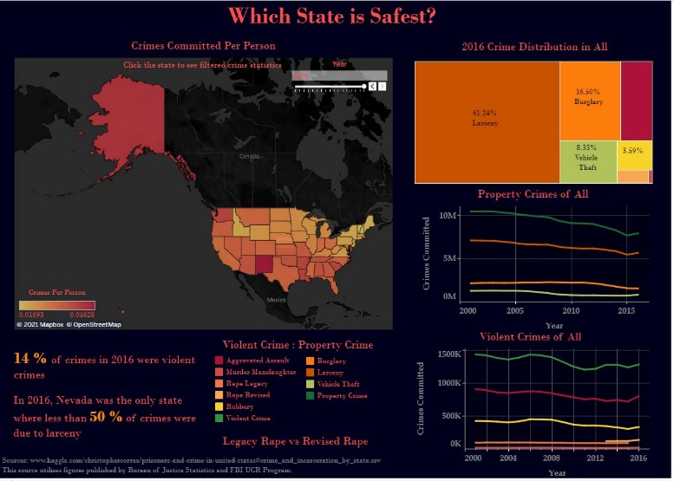

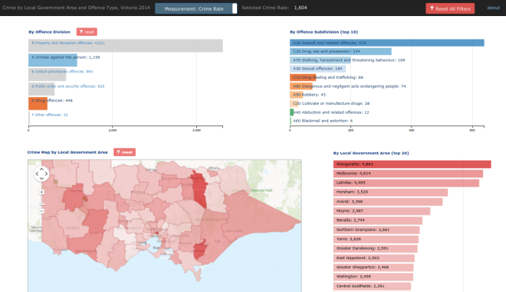

GITHUB REPOSITORY:  
<https://github.com/sherintm/crimedata-viz.git>

Team Members: Heejun SEO, Sherin Thomas, Neena Mani (Group 3)